

**SANYO SN-96BA53 1 Ton**

**Rs. 185,000/-**

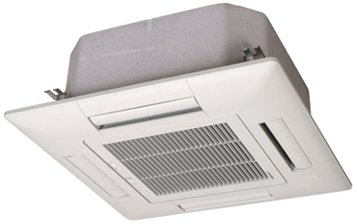

**Product Features**

* Independent Dehumidification
* Low Noise Air Flow System
* Easy Clean Panel
* Remote Control Pocket
* Three Minutes Protection

**Specification**

**Type** Ceiling Cassette AC

**Cooling (Btu/h)** 40000

**Voltage (V)** 220-240

**Power Input (W)** 3400

**EER (Btu/W-h-W/W)** 5.4-2.5